Computer Vision
Mainak Dutta
IRO2017009
Mtech 1st year, Robotics

Detecting Corners Using Harris Corner Detection
OpenCV has the function cv2.cornerHarris() for this purpose.
1. img - Input image, it should be grayscale and float32 type.
2. blockSize - It is the size of neighbourhood considered for corner detection
3. ksize - Aperture parameter of Sobel derivative used.
4. k - Harris detector free parameter in the equation.
CODE:
import cv2
import numpy as np
filename = 'Medical.jpg'
img = cv2.imread(filename)
#cv2.imshow('',img)
gray = cv2.cvtColor(img,cv2.COLOR_BGR2GRAY)
gray = np.float32(gray)
dst = cv2.cornerHarris(gray,2,3,0.04)
#cv2.imshow('',gray)
#result is dilated for marking the corners, not important
dst = cv2.dilate(dst,None)
# Threshold for an optimal value, it may vary depending on the image.
img[dst>0.05*dst.max()]=[0,0,255]
cv2.imshow('',dst)
cv2.imshow('Corner Detected',img)
cv2.waitKey(0)

OUTPUT:

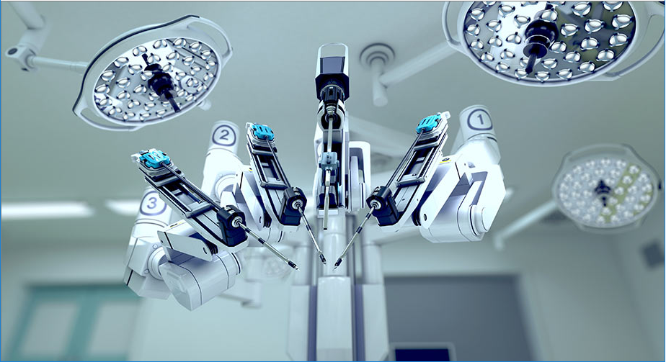

Fig :Original Picture

Output of Corner Detected Output By Harris Corner Detector:

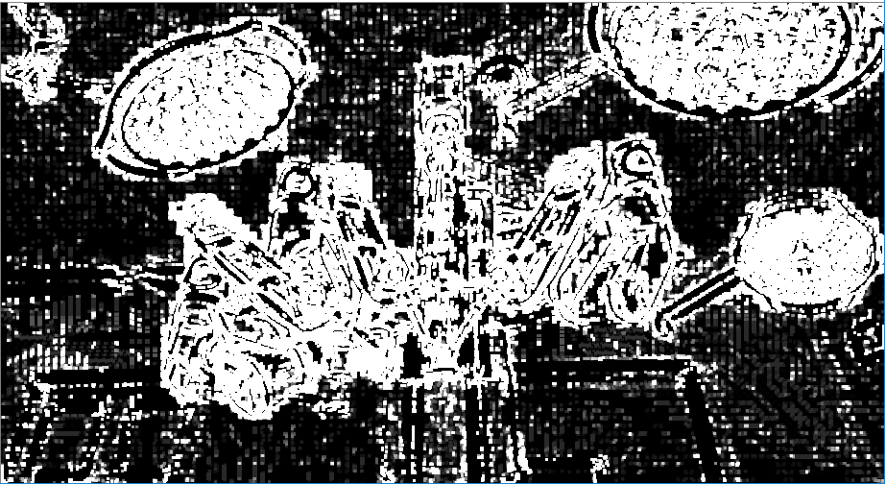

Output of original corner detected images with all the corners

